|  |  |  |  |  |  |  |  |  |  |  |  |  |  |  |  |  |  |  |  |
| --- | --- | --- | --- | --- | --- | --- | --- | --- | --- | --- | --- | --- | --- | --- | --- | --- | --- | --- | --- |
| Worship for the Lord's Day  November 11, 2018 – 30th Sunday in Ordinary Time 10:00 AM | | | | | | | | | | | | | | | | | | | |
| An asterisk * indicates standing, as you are able.  The congregation’s responses are in **bold italics**. | | | | | | | | | | | | | | | | | | | |
|  | | | Welcome | | | | | The Lord be with you. ***And also with you.*** | | | | | | | | | | | | |
|  | | | Announcements | | | | | | | | Please see the bulletin insert for all announcements. | | | | | | | | | | |
|  | | | Prelude | | | | Let There Be Peace on Earth | | | | | | | arr. Charity Boyles | | | | | | |
|  | | | In order to prepare for worship, you are invited to pray silently during the prelude. | | | | | | | | | | | | | | | | | |
|  | Call to Worship | | | | | | | |  | | | | | | | | | |
|  | | | Oh come, let us worship and bow down;  ***Let us kneel before the Lord, our Maker!***  For he is our God,  ***We are the people of his pasture, the flock of his hand.*** | | | | | | | | | | | | | | | |
| * | | Hymn | | | My Country, ‘Tis of Thee | | | | | | | | | | Hymnal #561 | | | |
|  | | Prayer of Confession | | | | | | | | | | | | | | | | |
|  | | | Gracious God, our sins are too heavy to carry, too real to hide, and too deep to undo. Forgive what our lips tremble to name, what our hearts can no longer bear, and what has become for us a consuming fire of judgment. Regenerate us more and more into the likeness and image of Christ, our Savior. Amen. | | | | | | | | | | | | | | | |
|  | | Assurance of Pardon | | | | | | | | | | | | | | | | |
|  | | So far he removes our transgressions from us.  ***Thanks be to God!*** | | | | | | | | | | | | | | | | |
| * | | Passing the Peace of Christ | | | | | | | | | | | | | | | | |
|  | | | | The peace of Christ is with you. ***And also with you.*** | | | | | | | | | | | | | | |
|  | | *All children 6 and younger are invited to Children’s Church in the nursery.* | | | | | | | | | | | | | | | | | | |
|  | |  | | | | | | | | | | | | | | | | | | |
| * | | Song of Praise | | | | | | Gloria Patri | | | | | | | | Hymnal #567 | | |
|  | | | Bulletin Gloria Patri 567.jpg | | | | | | | | | | | | | | | | | | |
| * | | | Profession of Faith | | | | | | | | | Apostles’ Creed (Traditional) | | | | | | |  | |
|  | | | | I believe in God the Father Almighty, Maker of heaven and earth, and in Jesus Christ his only Son our Lord; who was conceived by the Holy Ghost, born of the Virgin Mary, suffered under Pontius Pilate, was crucified, dead, and buried; he descended into hell; the third day he rose again from the dead; he ascended into heaven, and sitteth on the right hand of God the Father Almighty; from thence he shall come to judge the quick and the dead. I believe in the Holy Ghost; the holy catholic church; the communion of saints; the forgiveness of sins; the resurrection of the body; and the life everlasting. Amen. | | | | | | | | | | | | | | | | |
|  | | | Offering | | | | | The Navy Hymn | | | | | | | | | | John B. Dykes | | | |
|  | | | During the offertory, you are invited to offer silent prayers of gratitude. | | | | | | | | | | | | | | | | | | |
| * | | | Song of Thanksgiving | | | | | | | | | | Doxology | | Hymnal #593 | | | | | |

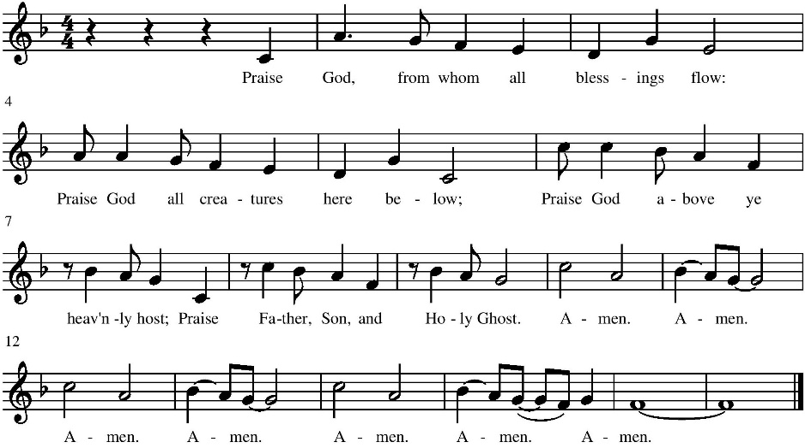

|  |  |  |  |  |  |  |  |  |  |  |  |  |  |  |  |
| --- | --- | --- | --- | --- | --- | --- | --- | --- | --- | --- | --- | --- | --- | --- | --- |
| * | Prayer of Dedication | | | | | | | | | | | | | | |
|  | Pastoral Prayer & The Lord’s Prayer | | | | | | | | | | | | | |
|  | | Our Father who art in heaven, hallowed be thy name. Thy kingdom come, thy will be done, on earth as it is in heaven. Give us this day our daily bread; and forgive us our debts, as we forgive our debtors; and lead us not into temptation, but deliver us from evil. For thine is the kingdom and the power and the glory, forever. Amen. | | | | | | | | | | | | | |
| * | Hymn | | | Lord of Light, Your Name Outshining | | | | | | | | | Hymnal #425 | | |
|  | Prayer for Illumination | | | | | | | | | | | | | | |
|  | First Scripture Lesson | | | | | | | | Hebrews 7:23-28 | | | | | p.1047 | |
|  | | | This is the word of the Lord. ***Thanks be to God!*** | | | | | | | | | | | | |
|  | Anthem | | | | | | | For His Own | | Dale Peterson | | | | | |
|  | Second Scripture Lesson | | | | | | | | Job 42:7-11 | | | | | p.464 | |
|  | | | This is the word of God for the People of God. ***Thanks be to God!*** | | | | | | | | | | | | |
|  | Sermon | | | | | "The Problem of Evil" | | | | | | | | | |
| * | Hymn | | | | Lift Every Voice and Sing | | | | | | | Hymnal #563 | | |
| * | Charge and Benediction | | | | | | | | | | | | | | |
|  | Postlude | | | | | | God of Our Fathers | | | | arr. Mary McDonald | | | | |

Announcements

The **sanctuary** **flowers** this morning are given by Carl & Brenda Cuthbertson for the glory of God and in honor of all Veterans.

The **Lay Reader** today is **Barbie Andrews.**

The **Youth Group Packing Party** for Operation Christmas Child will be immediately after worship today. Everyone is welcome to join them!

**Pastor Ed’s Bible Study** will meet this Tuesday, November 13, at 10 am at the church. This week's Bible Study will look at Ephesians 4:11-12, gifts for ministry to build up the body of Christ.

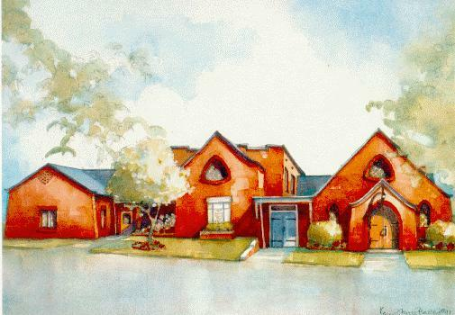

Altavista Presbyterian Church

A congregation of the Presbyterian Church (USA)  
 in the Presbytery of the Peaks



Our Mission

As members of the Body of Christ is to be  
His voice and hands helping all people.



Post Office Box 126 🞟 707 Broad Street 🞟 Altavista, Va. 24517  
Phone: 369-5286 🞟 Fax 369-1101 🞟 Pastor’s Cell: 434-219-5648  
E-mail: office@altapres.org  
Office hours: Monday—Thursday, 9:30 am—2:30 pm

Facebook: [www.facebook.com/altavistapc](http://www.facebook.com/altavistapc)

Website: www.altapres.org

Upcoming Events

|  |  |
| --- | --- |
| **November 4** | 10 AM Worship/Communion/Children’s Church Return OCC Items |
| **November 5** | 6 PM Ministry Beyond Meeting @ Church 7 PM Boy Scouts Meets in FH |
| **November 6** | 10 AM Bible Study Noon – Men’s Lunch-Tuscan Grill |
| **November 7** | 11-12:30 PM Second Helping Lunch 5:30 PM Property Meeting at the Church |
| **November 8** | 5:30 PM Worship Meeting at the Church |
| **November 11** | 10 AM Worship/Children’s Church OCC Packing Party after worship |
| **November 12** | 7 PM Boy Scouts Meets in FH |
| **November 13** | 10 AM Bible Study 6:00 PM Christian Ed Meeting @ Church |
| **November 14** | 9:30 APC Serves Lunch @ Daily Bread 9:30 AM Prayer Fellowship 10:30 AM Women’s Fellowship in Adult SS Room 11-12:30 PM Second Helping Lunch 1 PM DAWN Board Meeting |
| **November 17** | 7 AM Breakfast in Fellowship Hall 8 AM – 2 PM Clean-Up Day at APC |
| **November 18** | 10 AM Worship/Children’s Church Receive Thanksgiving Offering Congregational Meeting after Worship Session Meeting after Congregational Meeting |
| **November 19** | 7 PM Boy Scouts Meets in FH |
| **November 20** | 10 AM Bible Study Noon – Men’s Lunch-Main Street Café 1-5 PM Process Shoeboxes at OCC Processing Center |
| **November 21** | No Second Helping Lunch Church Office Closes at Noon December Link Deadline |
| **November 22** | Thanksgiving Day-Church Office Closed |
| **November 24** | 2-6 PM Process Shoeboxes at OCC Processing Center |
| **November 25** | 10 AM Worship/Children’s Church 5 PM Youth Group Meeting @ Church |
| **November 26** | 7 PM Boy Scouts Meets in FH |
| **November 27** | 10 AM Bible Study |
| **November 28** | 9:30 AM Prayer Fellowship 11-12:30 PM Second Helping Lunch |

People to Contact at APC

|  |  |
| --- | --- |
| Session (Active Elders)  Ron Coleman (’19) *Christian Education*  Kelly deBernard (’19) *Ministry Within the Congregation*  Kevin deBernard (’20) *Christian Education*  Susan Gilliam (’20) *Ministry Beyond the Congregation*  Carolyn Lees(’20) *Worship*  Stephanie Moehlenkamp (’19) *Worship*  Jack Ritzer (’20) *Ministry Support*  Mark Younkin (’19) *Property*  Rev. Ed Soto *Moderator of Session* | Staff  Rev. Ed Soto *Pastor*  Carolyn Doss  Church Secretary  John Erb  Clerk of Session  Dot Hogan  Organist  Dennis Janiak Treasurer  Stephanie Moehlenkamp  Choir Director  Other Contacts  Dolores Drumheller  Prayer Fellowship Request  Jack Ritzer The Men of the Church |

Schedules

|  |  |
| --- | --- |
| **Ushers, November** | Jack & Alline Ritzer The deBernard Family |
| **Lay Reader, November 18** | Martha Moore |
| **Lay Reader, November 25** | Cynthia Erb |
| **Nursery November 18** | Barbie Andrews |
| **Nursery November 25** | Need Someone |

***Altavista Presbyterian Church strives to show compassion to all people within our Congregation and beyond our doors just as Jesus showed compassion to all those in need.***

Joys and Concerns for Prayer

*Please contact the church office if you have prayer concerns.*

|  |  |
| --- | --- |
| Prayers For....   * God’s church here at APC and for His guidance. * Our session & church leaders. * Our nation and all our elected leaders. * Hospice patients and their caregivers. * Dianne Emmett * Ted Phillips * Arleatha Payne * Ryan Hedgepeth * Cynthia Erb | * Joyce Coleman * LeeAnn Head * Billy Robertson * June Lee * Jack Humphreys * Our service members: Jeremy Larkin, Grant Martin. * Our homebound members: Tim Coleman, Janet Sodders, Dean Smith, Essie Moore. * Those impacted by hurricane Florence and Michael. |

Announcements

The **Christian Education Committee** will meet this Tuesday, November 13, at 6:00 pm at the church.

**Prayer Fellowship** will meet this Wednesday at 9:30 am.

The **Women’s Fellowship** will meet this Wednesday, November 14, at 10:30 am in the adult Sunday School room.

**Dinner for Eight**, will be Saturday, November 17th, please sign-up on the bulletin board by today if you wish to participate.

The Property Committee has scheduled a **workday** at APC for this Saturday, November 17th. Breakfast will be served in the fellowship hall at 7 am, we will work until 2 pm. Please sign-up on the bulletin board if you plan to attend the breakfast.

The **Thanksgiving Offering will be collected** next Sunday, November 18, for the Presbyterian Children’s Home of the Highlands. This offering will be matched by our ACT for Missions funds. Please make checks payable to APC and indicate on the memo line or the pew envelope as Thanksgiving Offering.

Our fall **Congregational Meeting** will be held next Sunday, November 18, immediately after worship to present the 2019 Operating Budget, review & approve the Pastor’s 2019 Terms of Call and to elect the 2019 Nominating Committee.

The Worship Committee is looking for readers to help with our **Hanging of the Greens Service, December 2,** and families to light the **advent candles** for the other services in advent. Please sign up on the bulletin board if you would like to participate.

We have two opportunities to go to Charlotte to volunteer at the **Operation Christmas Child** Processing Center. The first is Tuesday, November 20, from 1-5 pm and the second is Saturday, November 24, from 2-6 pm. Youth must be at least 13 years old to participate. Please sign-up on the bulletin board by Today.

Volunteers are needed to host the upcoming **Koinonia** luncheons/dinners, please sign-up on the bulletin board.

**November DAWN Donation:** flour, stuffing mix